Wellness & The City: Best Places For Socially Distanced Beauty & Wellness Treatments
written by Cultivated Gazette
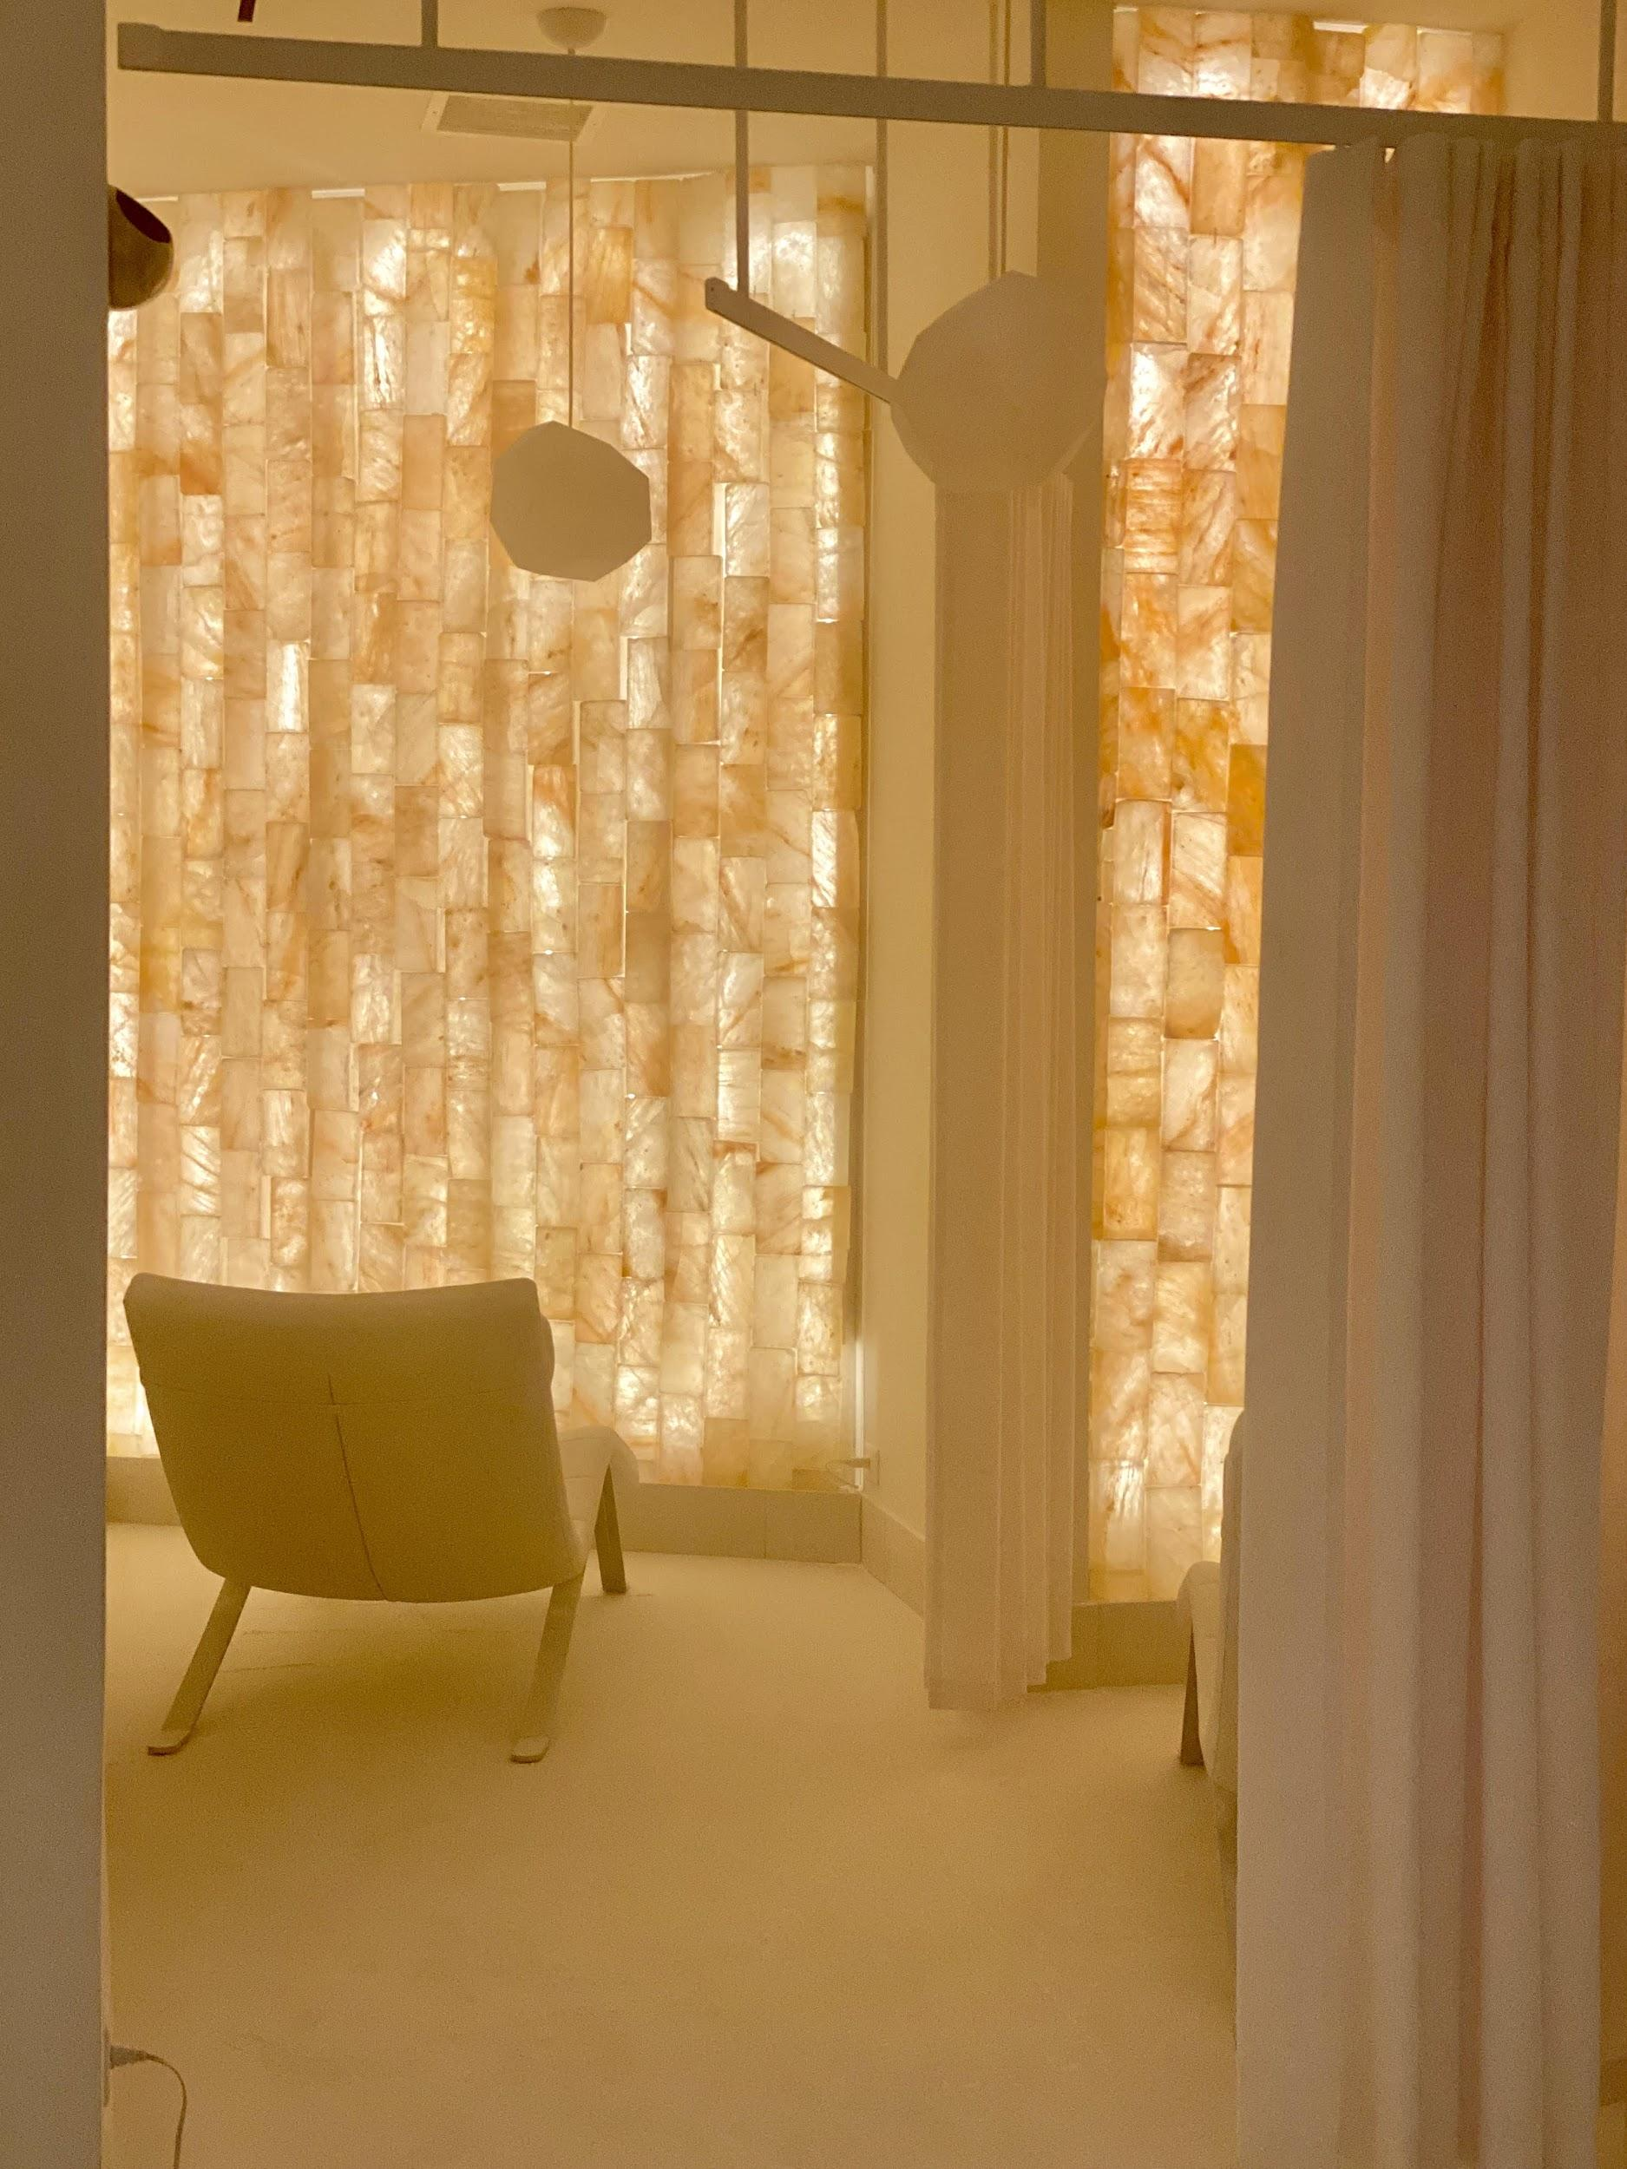
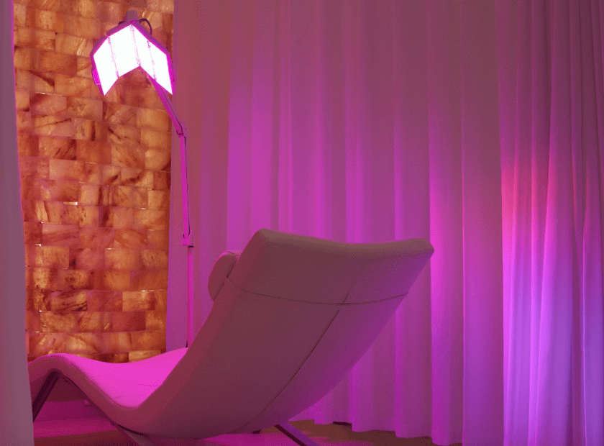
In today’s uncertain world escapism is the ultimate luxury. We combed our beloved city for socially distanced beauty and wellness treatments – three places helped us indulge in beauty and wellness, standing out as the best and safest to help us practice self-care.
SALT LIVE ENERGIZED
180 Avenue of the Americas
Respiratory health and immune health should be our priority, and salt therapy has the potential to become your new favorite pastime. While we have been to a number of salt rooms in the city (each unique in their own way), SALT is the only one that focuses solely on the respiratory system and makes their own body care line of products.
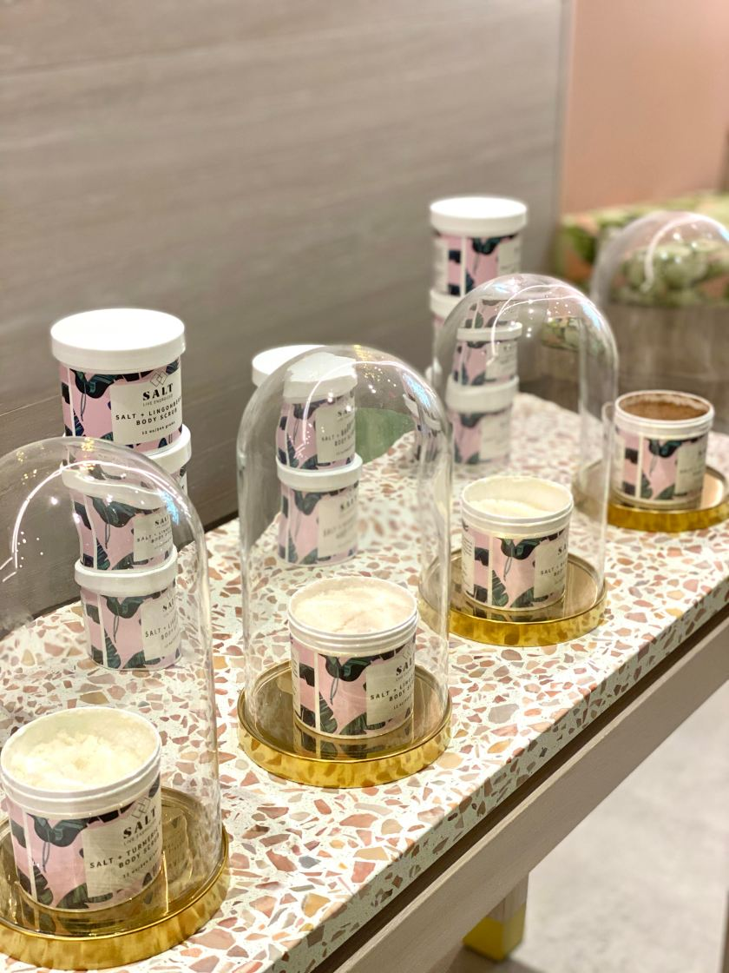SALT Live Energized Body Care Products
Salt air therapy is natural and it is what makes SALT unique is the dry particles of pharmaceutical grade salt, as small as 1 micrometer (aka “micron”), released in a low humidity environment. We can tell you about the science of it all, but instead we’ll just tell you that our sinus headache was relieved upon exit. So what happens in the room you ask? Come in wearing loose clothing or a robe will be provided. You will be booked for a private space and given BOSE headphones with relaxing music on an iPod, a bottle of water, socks, tissues, and if you book the Face LED Stimulus Treatment, light protective eye goggles. There is very minimal contact with staff, it is just you and the salt room. Relaxing in this space, listening to crashing waves and singing birds, feels like a vacation. Knowing you’re doing something positive for your health feels even better. Visiting SALT is like a day at the beach (including the salt sticking to your clothing and hair), and it is the 45 getaway all New Yorkers need right now. Our city needs more wellness spaces just like this, and while we wait, you can find us in the salt room.
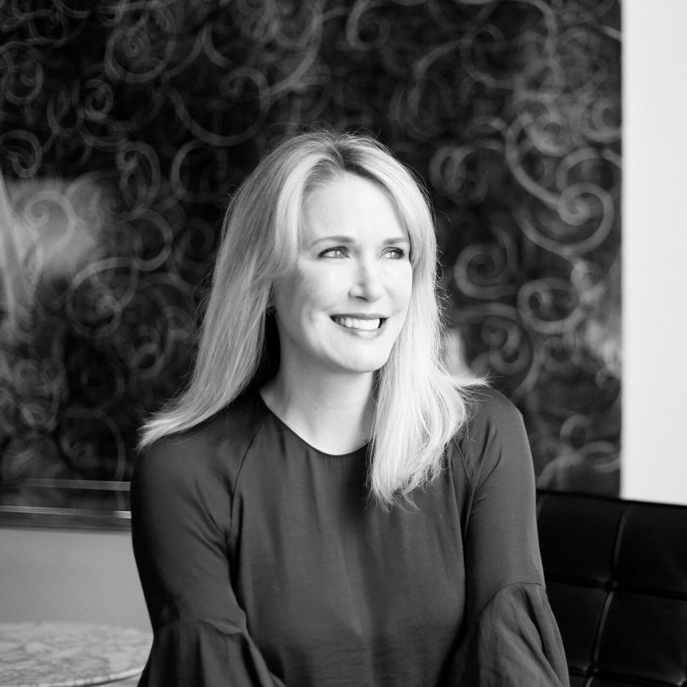
Jillian Wright
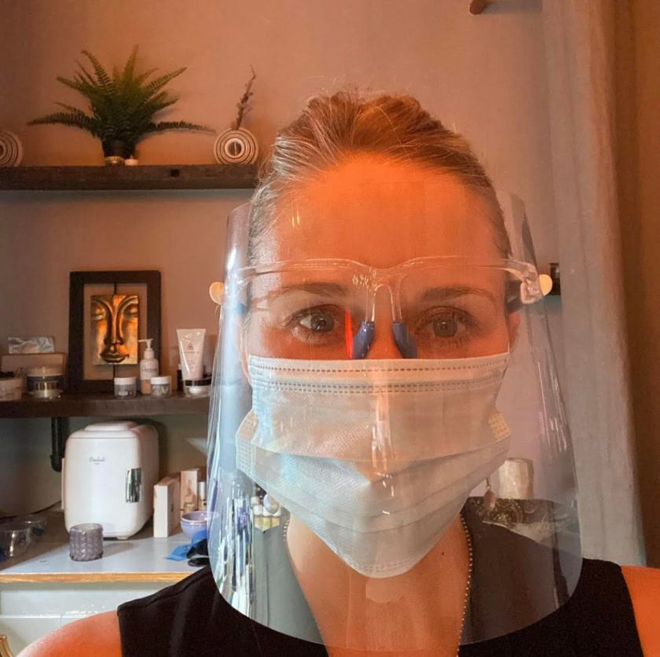
Bloom Skincare Lounge
BLOOM BEAUTY LOUNGE WITH JILLIAN WRIGHT
140 W 19th St
If you can’t give up on getting a facial choose a customized experience with an aesthetician who takes the virus seriously, then keep them in your social circle. A well-known New York City aesthetician and founder of the Indie Beauty Expo has decided to get back to what she loves most: treating skin and giving out skincare advice. You too can be blessed with getting a facial from this pro by booking an appointment at her new skincare suite, Bloom Beauty Lounge.
Jillian Wright tells us, “I have teamed up with a former Aesthetician of mine, Samantha Roberts. We approach skincare holistically but also with result-oriented modalities and techniques. We partner with our clients to achieve long term healthy skin goals. We do this by customizing facials, acne management, and plasma skin tightening. I explain Plasma Skin Tightening here and here. We only take one client at a time and for me 3 max in a day to allow more time in between. I also get covid tested often and have strict guidelines for people coming in to get a facial. We provide a very safe environment. Obviously we are not hands-free, but we take every precaution necessary to put clients at ease.”
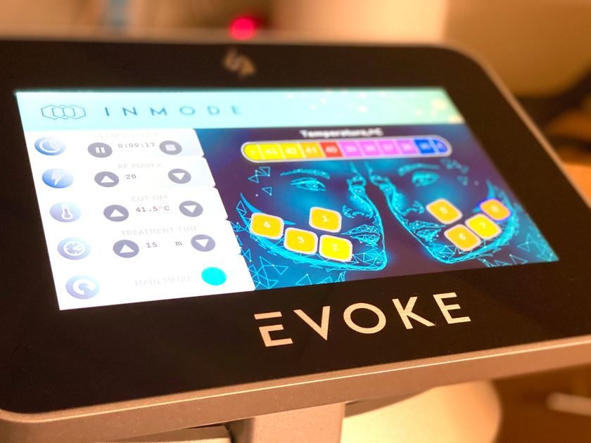Evoke screen during treatment
EVOKE AT LUXURY DENTISTRY NYC
328 E 75th St
For those who seek non-invasive and socially distanced facial remodeling and tightening treatments, Evoke has become a favorite among the skincare obsessed and it could be your hands-free go-to as well. This type of treatment is an industry first and we were invited to try Evoke at Luxury Dentistry with Dr. Steven Davidowitz. The quick treatment can be done on your lunch break and since there is no downtime, you can go right back to being on Zoom. The entire experience felt safe, due to strict safety measures, from the moment we entered the door to the way the treatment works. A couple of weeks later we see a more refined jaw area.
Dr. Steven Davidowitz
How does it work? Evoke uses clinically proven, and FDA approved, radio frequency technology. Each session lasts between 15 to 45 minutes. The only interaction you’ll experience is with a technician who places the device on you. The device looks like large headphones. From there you are free to relax with a call button closely nearby. While the treatment is pain-free, you will feel a warming sensation (like a warm stone massage) – which we found to have a comfortable temperature. Evoke remodels the dermis and subdermal tissue to deliver more defined facial characteristics. There are two treatments, one for the face and one for the chin. Largely it is the best treatment for older patients, but younger candidates looking to refine their chin or face can benefit from the treatment as well. Besides remodeling, Evoke increases circulation, rejuvenates skin tone and makes the skin tighter. Hands-free treatments are looking to be the future our industry.

