How to Make Your Daily Beauty Routine More Hygienic
Julie Ricevuto •Apr 6, 2020
Updated on Apr 14, 2020
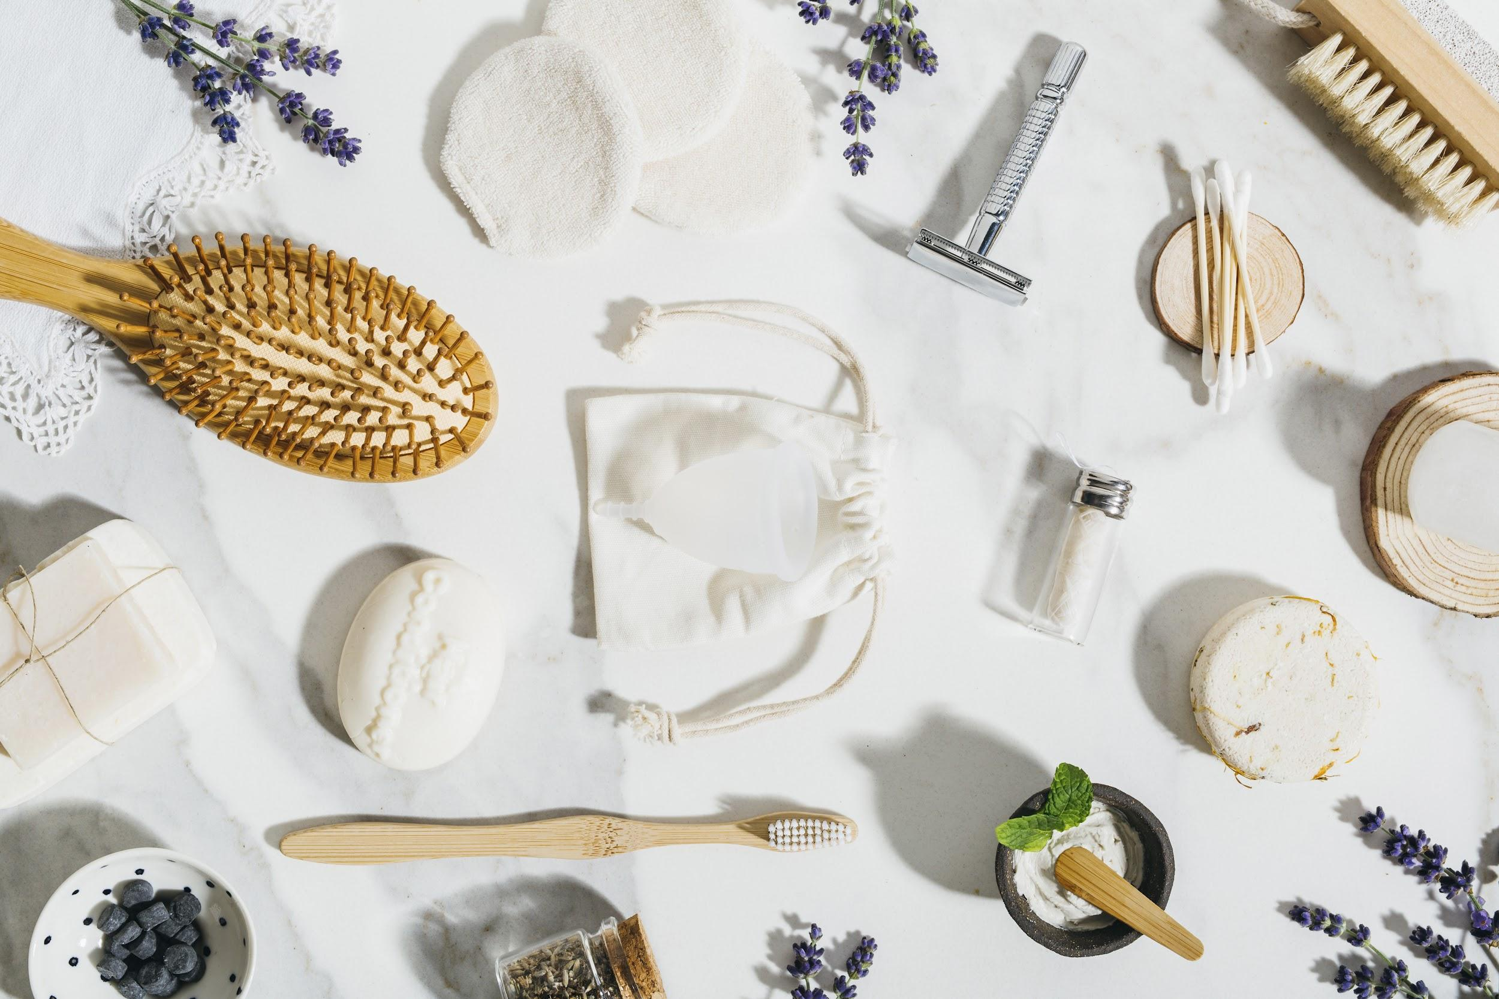
Dermatologists and aestheticians have been telling us not to touch our faces for years— and now you can add the Centers for Disease Control and Prevention (CDC) to the mix. Pre-coronavirus, it seemed like the worst thing that could happen from disregarding this tip was spreading unsightly breakouts; but with a virus on the loose, mindlessly rubbing your eyes or putting fingers near your mouth can put you at risk for getting sick.
But it’s basically impossible to have a skin-care routine (or even brush your teeth) without touching your face, so stepping up beauty hygiene becomes even more essential. We tapped top experts in the beauty industry to help ensure you know how to keep your daily regimen as sanitary as possible.

Tip #1: Wash your hands
You’ve probably already heard this a million times, but scrub up like a surgeon before even thinking about starting your skin-care regimen. “The first step is to always wash your hands before starting your routine,” says celebrity esthetician Shani Darden. According to the CDC, you should wash your hands—under the fingernails included—thoroughly with soap and water, cleansing for at least 20 seconds before drying off on a clean towel. Once your hands are sufficiently clean, you can begin your morning or night beauty routine.
Related: Celebrity Aesthetician Shani Darden Reveals the Skin-Care Ingredient She’s Used for More Than 10 Years

Tip #2: Thoroughly clean your makeup applicators
While under quarantine, you’re most likely not wearing too much makeup. But if you are still putting some on for those daily Zoom meetings, it’s important to keep your makeup brushes clean. “Make sure you’re thoroughly cleansing your brushes at least once a week, if not more often,” says Darden.
Makeup sponges can harbor nasties, so clean them often with lukewarm water and a cleanser. “Makeup sponges are especially prone to growing mold,” says board-certified dermatologist in La Jolla, California, Dr. Azadeh Shirazi. You can also try a product like the Beautyblender Liquid Blendercleanser ($18), which breaks down makeup and bacteria when applied on both makeup brushes and foam applicators. If a special brush cleanser isn’t available, hand soap is another foolproof option. Dr. Shirazi also recommends a “natural distilled white-vinegary solution, for removing yeast and bacteria” from sponges—although no natural solutions have been officially recommended to protect against coronavirus.

Tip #3: Use skin-care spatulas or pump dispensers
“If you’re using any products in a jar, make sure you’re not dipping your hands or fingers into them, because that can contaminate the product,” warns Darden. “I always keep a stash of small plastic spatulas on hand that I can throw out after each use.” Luckily, you can buy mini spatulas—which are perfect for scooping out product from a jar—on Amazon for less than $10.
For those who prefer to skip the spatulas, Dr. Shirazi recommends opting for moisturizers in a pump container rather than a jar because it keeps your creams sealed and unexposed to potential contaminants.

Tip #4: Try toothpaste tablets or use a Q-tip when sharing toothpaste
For most of us, the process of brushing our teeth goes as follows: take the tube of toothpaste and rub it across the bristles of the toothbrush before brushing. If you live with another person, it’s common for them to also use that same toothpaste and rub it across the bristles of their toothbrush too. Obviously, this can spread bacteria from person to person. In order to extra hygienic, Dr. Steven Davidowitz recommends using a Q-tip to transfer toothpaste from a brand new tube and onto your toothbrush. “Use a little bit more than you would normally put on your toothbrush, because it’s not all going to transfer,” he warns. “What [this does] is save the [toothpaste] from becoming cross-contaminated.”
Another option is to use toothpaste tablets, which are designed for individual use. Hello Antiplaque + Whitening Toothpaste Tablets ($9) contain natural peppermint, tea tree oil, and coconut oil to cleanse teeth. To use, simply pop a tablet into your mouth, chew it until a soft paste forms, wet your toothbrush, and begin brushing.
Related: 8 Ways to Take Care of Your Teeth When You Can’t See a Dentist

Tip #5: Use individual floss picks rather than dispensers
Dr. Davidowitz says it’s a lot more hygienic to use single-use floss products, like the Plackers Micro Mint Dental Flossers ($12), rather than share a single dispenser of floss, even within a household. “Many people are sharing a dispenser of floss with others—and many times [people reach for floss] after touching their mouth while brushing,” he explains.

Tip #6: Store skin-care products outside of the bathroom
Although modern-day makeup and creams are made with preservatives to keep them from growing yeast and bacteria, they can still become contaminated over time. “When skin-care and makeup products are kept in a bathroom, where moisture tends to accumulate, there’s a risk of yeast overgrowth in these products,” says Dr. Shirazi. Instead, store your products in a cool, dry environment—not loose on your bathroom countertop—to help reduce the risk of bacteria accumulating.

Tip #7: Don’t share beauty products
Sadly, it’s time to wipe the notion of “Sharing is caring” from your brain. “Avoid sharing items applied close to mucous membranes, such as lipsticks, lip balms, eyeliners, mascara, and lip liners,” says Dr. Shirazi. Sharing these kinds of items can spread bacteria—and potentially infection—from person to person.

Tip #8: Use isopropyl alcohol on beauty tools
Let’s face it, we’ve all been guilty of being a bit less sanitary than we should be, when it comes to our beauty tools. But now it’s more important than ever before to break that habit. “Wipe down lipsticks and makeup cases regularly with disinfecting wipes,” says Dr. Shirazi. “Use isopropyl alcohol to clean tools like tweezers or lash curlers.”

